Team Id – 25WSC1BAI02

Title : Man-in-the-Middle on Diffie-Hellman

Name – Nikhil Parkar
Reg no – 23BAI1199

Name – Priyanshu Solanki
Reg no – 23BAI1206

Name – Kuchibhotla Nischay
Reg no – 23BAI1245

Abstract

This project presents a comprehensive study on securing the Diffie-Hellman key exchange, which, although widely used for secure key agreement, is vulnerable to Man-in-the-Middle (MITM) attacks due to the absence of authentication. The work begins with the implementation of the basic Diffie-Hellman protocol and demonstrates how an attacker can intercept and manipulate public key exchanges to establish separate shared secrets with communicating parties.
To address this vulnerability, authentication mechanisms are incorporated using the ElGamal Digital Signature and the RSA algorithm, ensuring the integrity and authenticity of exchanged parameters. Additionally, Cryptographic hash function techniques are applied to enhance data integrity and protect against message tampering.
The project further explores a critical implementation flaw in ElGamal signatures—reuse of the random nonce k. It is demonstrated that reusing k across different messages leads to the exposure of the private key through solvable modular equations. A prevention mechanism enforcing the use of fresh random nonces for each signature is implemented to eliminate this vulnerability.
The system is developed with a graphical user interface using Tkinter to simulate communication between parties, visualize attacks, and demonstrate security enhancements. Experimental results are analyzed through multiple graphs, including MITM success rate before and after authentication, time complexity versus key size, authentication success rate, and latency overhead.
The results confirm that while Diffie-Hellman alone is insecure, the integration of digital signatures and proper cryptographic practices effectively mitigates both MITM attacks and nonce reuse vulnerabilities, ensuring a robust and secure key exchange mechanism.

Introduction
The Diffie-Hellman key exchange is a fundamental cryptographic technique that enables two parties to establish a shared secret over an insecure communication channel. It is widely used in modern secure communication systems due to its simplicity and effectiveness in key agreement. However, the protocol lacks an inherent mechanism for authentication, making it vulnerable to Man-in-the-Middle (MITM) attacks, where an attacker can intercept and alter the exchanged public values.
To overcome this limitation, authentication mechanisms such as the ElGamal Digital Signature and the RSA algorithm are integrated with the Diffie-Hellman protocol. These techniques ensure that the communicating parties can verify each other's identity and detect any unauthorized modifications to the transmitted data. Additionally, Cryptographic hash function functions are used to maintain data integrity.
Despite these improvements, improper implementation of cryptographic algorithms can introduce new vulnerabilities. One such issue is the reuse of the random nonce k in ElGamal signatures, which can lead to the exposure of the private key. This project not only demonstrates these vulnerabilities but also implements effective prevention techniques, providing a comprehensive understanding of both theoretical and practical aspects of secure communication.

Problem Statement
The Diffie-Hellman key exchange protocol, while effective for secure key generation, is inherently vulnerable to Man-in-the-Middle (MITM) attacks due to the absence of authentication. An attacker can intercept and modify public key exchanges, leading to compromised communication without detection.
Furthermore, even when authentication mechanisms such as ElGamal and RSA digital signatures are applied, improper implementation such as the reuse of the random nonce k in ElGamal signatures can result in critical security breaches, including the exposure of private keys.
Therefore, there is a need to:
- Analyze vulnerabilities in the Diffie-Hellman protocol
- Implement secure authentication mechanisms
- Identify and demonstrate implementation-level attacks
- Develop and apply effective prevention techniques
to ensure a robust and secure key exchange system.

Objectives
The main objectives of this project are:
- To implement the Diffie-Hellman key exchange and demonstrate its vulnerability to MITM attacks.
- To simulate Man-in-the-Middle attacks and analyze their impact on secure communication.
- To enhance security by integrating ElGamal Digital Signature and RSA algorithm for authentication.
- To use Cryptographic hash function techniques to ensure data integrity.
- To demonstrate the reused k vulnerability in ElGamal signatures and recover the private key.
- To implement prevention techniques by enforcing fresh random nonce generation for each signature.
- To compare system performance using graphs such as success rate, time vs key size, authentication rate, and latency overhead.
- To develop a user-friendly GUI using Tkinter to visualize attacks, prevention mechanisms, and secure communication flow.

Literature Survey

[1] Stallings, W. (2017). Cryptography and Network Security: Principles and Practice (7th ed.). Pearson Education.
William Stallings' textbook is the most widely adopted academic reference in network security courses worldwide and provides exhaustive coverage of all components relevant to this topic. The book dedicates full chapters to the Diffie-Hellman key exchange protocol, explaining its mathematical foundation in modular arithmetic and the discrete logarithm problem. Stallings clearly illustrates how the absence of authentication in the basic DH protocol exposes it to Man-in-the-Middle attacks, where an adversary intercepts and replaces the public values exchanged between two parties, establishing independent shared secrets with each without their knowledge. The book then presents countermeasures, including digital signature schemes such as ElGamal and DSA, which bind the sender's identity to the exchanged public key. Stallings also covers SHA-256 as part of the SHA-2 family of cryptographic hash functions and HMAC as a keyed message authentication construct. His treatment of these topics as a unified security framework — where signatures provide authentication and HMAC provides integrity — makes this textbook an essential theoretical backbone for understanding the complete MITM prevention model.
[2] Menezes, A. J., van Oorschot, P. C., & Vanstone, S. A. (1996). Handbook of Applied Cryptography. CRC Press.
The Handbook of Applied Cryptography is one of the most rigorous and comprehensive cryptography references ever published, freely available and widely cited in both academic and industry contexts. The book formally defines the Diffie-Hellman key agreement protocol and provides a thorough mathematical analysis of the discrete logarithm problem upon which its security rests. A dedicated section covers active attacks including the MITM scenario, where the authors explain precisely how an attacker can impersonate both parties during a DH handshake. The handbook then covers the ElGamal signature scheme in full mathematical detail, describing key generation, the signing algorithm using a random ephemeral key, and the verification equation — showing clearly how this signature can authenticate a DH public value and prevent impersonation. Hash functions and MAC constructions including HMAC are also discussed rigorously, with formal security definitions. The handbook's depth makes it the definitive reference for researchers who require mathematical proofs and complete algorithmic specifications rather than intuitive descriptions.

[3] Schneier, B. (1996). Applied Cryptography: Protocols, Algorithms, and Source Code in C (2nd ed.). John Wiley & Sons.
Bruce Schneier's Applied Cryptography is a landmark book that bridges theoretical cryptography with hands-on implementation, making it invaluable for both developers and researchers. Schneier provides accessible yet thorough explanations of the Diffie-Hellman protocol, explicitly warning readers about its vulnerability to MITM attacks in the absence of authentication. He dedicates substantial coverage to digital signature algorithms, including the ElGamal scheme, describing how signatures can be used to certify public key material during an exchange and thereby defeat MITM adversaries. The book also covers hash functions and keyed MAC constructions, explaining how HMAC-like constructs can guarantee message authenticity in protocols where a shared secret already exists. Schneier's unique strength is his discussion of how cryptographic primitives can fail in practice — not just in theory — illustrating real-world attack scenarios and showing why combining DH with signatures and MACs is necessary. His practical perspective, illustrated with C pseudocode and protocol diagrams, makes this book a foundational reference for implementing MITM-resistant key exchange systems.

[4] Paar, C. & Pelzl, J. (2010). Understanding Cryptography: A Textbook for Students and Practitioners. Springer.
Paar and Pelzl's Understanding Cryptography is a modern pedagogically excellent textbook that provides a clean, step-by-step treatment of all relevant cryptographic building blocks including DH key exchange, hash functions, MACs, and digital signatures. The book presents the Diffie-Hellman protocol with detailed worked examples, showing how both parties independently compute the same shared secret, and explicitly identifies the MITM vulnerability as a consequence of lacking identity binding. It devotes a full chapter to cryptographic hash functions, covering the SHA-2 family including SHA-256, explaining the Merkle-Damgård construction and avalanche effect properties that make SHA-256 collision-resistant. The authors then extend this to HMAC, showing how wrapping SHA-256 with a secret key converts a one-way hash into a message authentication code suitable for verifying both integrity and authenticity. The ElGamal signature scheme is covered alongside DSA as an example of discrete-logarithm-based signatures. Paar and Pelzl's book is particularly effective for readers who want a unified mathematical narrative that naturally leads from the DH vulnerability to the cryptographic tools — SHA-256, HMAC, and ElGamal — that resolve it.

[5] Forouzan, B. A. (2007). Cryptography and Network Security. McGraw-Hill.
Behrouz Forouzan's textbook presents cryptography and network security with a communications engineering perspective, making it especially approachable for students from networking backgrounds. The book explains the Diffie-Hellman protocol as a key-establishment mechanism used in protocols such as SSL/TLS and IPSec, and clearly diagrams how a MITM attacker intercepts the exchange by substituting their own public values for those of the legitimate parties. Forouzan dedicates chapters to message integrity and message authentication, covering SHA-256 as the recommended hash standard and HMAC as the standard keyed authentication mechanism. The book also covers asymmetric signature schemes including ElGamal, explaining how digital signatures on public key values can provide the identity assurance that plain DH lacks. Forouzan's treatment is particularly strong in showing how these mechanisms combine within real protocols: for example, how TLS uses a combination of DH for key exchange, digital certificates for authentication, and HMAC for record-layer integrity. This integrated protocol-level perspective makes the book an ideal reference for understanding end-to-end MITM prevention in real systems.

[6] Katz, J. & Lindell, Y. (2020). Introduction to Modern Cryptography (3rd ed.). CRC Press / Chapman & Hall.
Katz and Lindell's Introduction to Modern Cryptography is considered the gold standard academic text for cryptography at the graduate level, presenting the subject through the lens of formal definitions, security reductions, and provable security. The book rigorously defines the Diffie-Hellman assumption and the computational Diffie-Hellman (CDH) and decisional Diffie-Hellman (DDH) problems, establishing the formal basis for both DH security and its limitations. The MITM attack is formalized as a failure of authenticated key exchange, and the authors present the theoretical conditions under which a key exchange protocol can be proven secure against active adversaries. HMAC is treated in the context of message authentication codes with formal security definitions, and SHA-256 is discussed as a collision-resistant hash function whose properties underpin HMAC's security proof. ElGamal signatures are analyzed as an instance of the Fiat-Shamir paradigm applied to a discrete-log identification scheme. By grounding every construction in provable security theory, this textbook provides the strongest formal justification for why the combination of HMAC and ElGamal signatures is both necessary and sufficient to prevent MITM attacks on Diffie-Hellman.

[7] Bishop, M. (2018). Computer Security: Art and Science (2nd ed.). Addison-Wesley / Pearson.
Matt Bishop's Computer Security: Art and Science is a comprehensive computer security textbook that places cryptographic protocols within the broader context of system security, threat modeling, and security policy. The book introduces MITM attacks as a class of active network attacks and explains how they exploit the trust assumptions of unauthenticated protocols like basic Diffie-Hellman. Bishop discusses cryptographic authentication mechanisms including digital signatures and MACs as the principal defenses against such active attacks, tying these tools to formal security models such as the Dolev-Yao attacker model. SHA-256 is discussed as part of the secure hash standard and its role in both digital signatures and HMAC. The ElGamal signature scheme is presented alongside RSA signatures as a comparison of integer factorization versus discrete logarithm based security. Bishop's distinctive contribution is contextualizing these cryptographic tools within threat models and access control policies, showing that MITM prevention is not just a cryptographic problem but an architectural and policy problem that requires proper key management, certificate infrastructure, and protocol design discipline alongside the mathematical tools.

[8] Kaufman, C., Perlman, R., & Speciner, M. (2002). Network Security: Private Communication in a Public World (2nd ed.). Prentice Hall.
Kaufman, Perlman, and Speciner's textbook is uniquely focused on the practical deployment of security protocols in real networks, making it an outstanding reference for understanding how MITM attacks occur in actual network environments and how they are countered. Radia Perlman, herself an inventor of foundational networking protocols, brings exceptional insight into how protocol design choices create or eliminate attack surfaces. The book gives detailed coverage of the Diffie-Hellman exchange and walks through the MITM attack step by step at the protocol message level, illustrating exactly which messages an attacker intercepts and replaces. The authors discuss how adding digital signatures including ElGamal and RSA-based schemes to the DH handshake binds public values to verified identities, closing the MITM vulnerability. HMAC with SHA-256 is discussed as the preferred integrity mechanism for authenticated key exchange protocols. The book further explores real-world deployments such as IKE (Internet Key Exchange) and SSL/TLS, showing how these protocols combine DH, signatures, and HMAC in practice. This makes it an essential reference for implementation-oriented research on MITM prevention.

[9] Stinson, D. R. & Paterson, M. (2018). Cryptography: Theory and Practice (4th ed.). CRC Press.
Stinson and Paterson's Cryptography: Theory and Practice is a mathematically rigorous textbook used extensively in university cryptography courses, providing clean theorem-proof treatments of all relevant schemes. The book thoroughly develops the number-theoretic foundations — Fermat's little theorem, primitive roots, discrete logarithms — that underpin the Diffie-Hellman protocol and the ElGamal signature scheme. The MITM attack on DH is presented formally, and the authors prove that unauthenticated DH cannot achieve authenticated key exchange under standard adversarial models. The ElGamal signature scheme is defined and analyzed, with a discussion of how its security reduces to the discrete logarithm problem, and how it can be used to authenticate public key values during a DH exchange. Hash functions including SHA-256 are covered in the context of collision resistance, preimage resistance, and second-preimage resistance, and HMAC is derived and analyzed as a secure MAC built from these primitives. Stinson and Paterson's rigorous mathematical approach makes this book ideal for readers who wish to understand the formal security guarantees that SHA-256, HMAC, and ElGamal signatures provide in the MITM prevention context.

[10] Ferguson, N., Schneier, B., & Kohno, T. (2010). Cryptography Engineering: Design Principles and Practical Applications. Wiley Publishing.
Cryptography Engineering by Ferguson, Schneier, and Kohno is a practitioner-oriented textbook that focuses on correctly designing, implementing, and deploying cryptographic systems in real applications — an area where many systems fail despite using mathematically sound primitives. The book presents SHA-256 and the SHA-2 family as the recommended hash functions for all new systems, explaining their internal construction and warning against common misuse patterns such as naive hash-based MACs (which are vulnerable to length extension attacks). HMAC is presented as the correct solution to keyed message authentication, with detailed discussion of its construction and the implementation pitfalls developers must avoid. The book covers key exchange protocols and dedicates significant attention to the MITM problem, emphasizing that any key exchange protocol deployed without mutual authentication is insecure regardless of its mathematical strength. Digital signatures, including ElGamal-derived schemes, are discussed as the most robust mechanism for achieving mutual authentication in asymmetric settings. Ferguson, Schneier, and Kohno's engineering mindset — "how do you build this correctly in the real world?" makes this book an indispensable complement to theoretical texts and a critical reference for implementing MITM-resistant DH systems using SHA-256, HMAC, and ElGamal signatures.

Mathematical Background and Justification


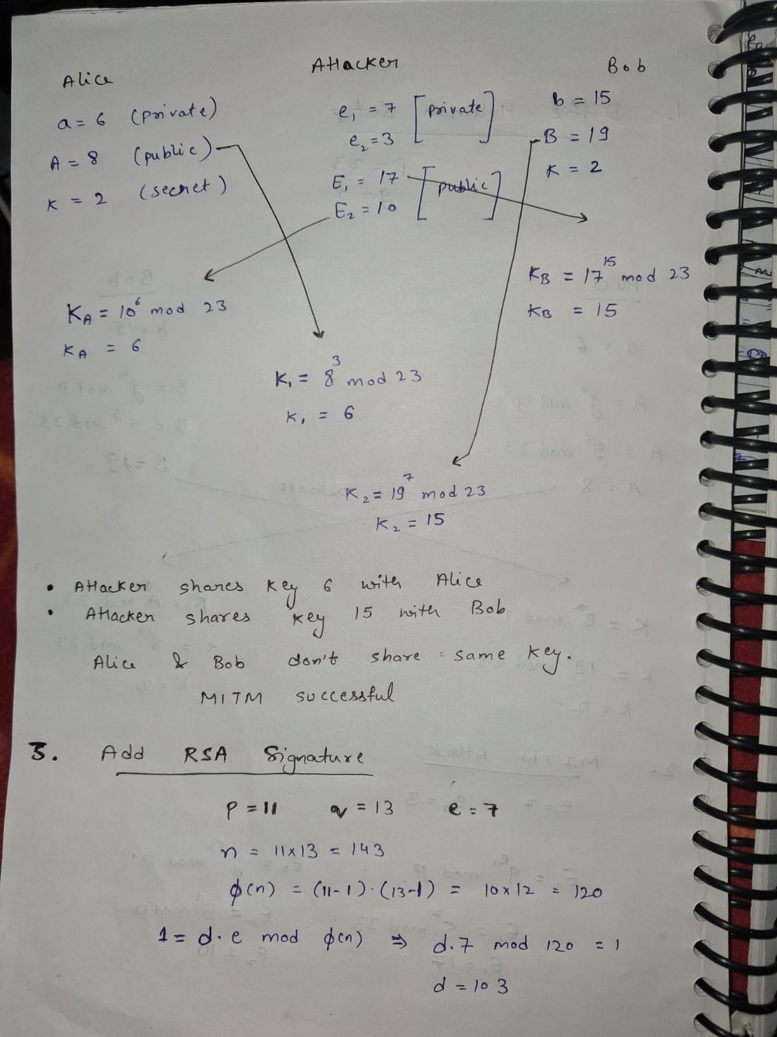



System Model
The system is designed to simulate secure communication between two legitimate parties using the Diffie-Hellman key exchange. The goal is to establish a shared secret key over an insecure channel and then enhance its security using authentication mechanisms such as the ElGamal Digital Signature, RSA algorithm, and Cryptographic hash function.

Entities in the System
The system consists of three main entities:
- Alice (Sender)
  - Initiates communication
  - Generates private key $a$
  - Computes public value $g^{a}mod p$
  - Signs the value using ElGamal/RSA
- Bob (Receiver)
  - Responds to Alice
  - Generates private key $b$
  - Computes public value $g^{b}mod p$
  - Verifies Alice’s signature and signs his own value
- Attacker (Man-in-the-Middle)
  - Intercepts communication
  - Modifies transmitted values
  - Attempts to establish separate keys with Alice and Bob

Normal Secure Communication Flow
The communication process is divided into the following steps:
- Parameter Generation
  - Public parameters $p$(prime) and $g$(generator) are generated.
  - These values are shared among all parties.
- Key Exchange
  - Alice computes $A=g^{a}mod p$
  - Bob computes $B=g^{b}mod p$
- Authentication
  - Alice sends:
$$\left(A,{\text{Sign}}_{A}(A)\right)$$
  - Bob verifies the signature using Alice’s public key.
  - Bob sends:
$$\left(B,{\text{Sign}}_{B}(B)\right)$$
  - Alice verifies Bob’s signature.
- Shared Key Computation
  - Alice computes:
$$K=B^{a}mod p$$
  - Bob computes:
$$K=A^{b}mod p$$
Since both values are equal:
$$K=g^{ab}mod p$$

Security Features in the System
- Confidentiality: Achieved through Diffie-Hellman key exchange
- Authentication: Provided by ElGamal and RSA signatures
- Integrity: Ensured using SHA-based hashing
- Replay Protection: Achieved through nonce/random values

Attack Model
The attack model focuses on two major vulnerabilities:
Man-in-the-Middle (MITM) Attack
In the basic Diffie-Hellman protocol, no authentication mechanism exists. This allows an attacker to intercept and manipulate communication.
Attack Flow
- Alice sends:
$$A=g^{a}mod p$$
- Attacker intercepts and replaces:
$$A→A^{'}$$
- Bob receives fake value $A^{'}$
- Bob sends:
$$B=g^{b}mod p$$
- Attacker intercepts and replaces:
$$B→B^{'}$$

Result of Attack
- Alice computes:
$$K_{1}=(B^{'})^{a}$$
- Bob computes:
$$K_{2}=(A^{'})^{b}$$
- Attacker computes:
  - $K_{A}=(A)^{c}$
  - $K_{B}=(B)^{c}$
Two different keys are established
Attacker can read and modify all messages
- > Why Attack Succeeds
- No identity verification
- Public values are not authenticated
- Anyone can impersonate sender/receiver

-> Prevention Using Digital Signatures
To prevent MITM attacks, authentication is introduced:
- Each public value is digitally signed
- Receiver verifies authenticity before accepting

✔ Secure Flow
- Alice sends:
$$\left(A,{\text{Sign}}_{A}(A)\right)$$
- Bob verifies:
  - If valid → accept
  - Else → reject
Attacker cannot forge signatures → attack fails

Reused k Attack in ElGamal Signature
Even after securing DH, improper implementation of ElGamal signatures introduces another vulnerability.

Attack Condition
- Same random nonce $k$used for two messages:
$$\left(r,s_{1}),(r,s_{2}\right)$$

Mathematical Exploitation
$$s_{1}=k^{-1}(m_{1}-xr) \\ s_{2}=k^{-1}(m_{2}-xr)$$
Subtract:
$$s_{1}-s_{2}=k^{-1}(m_{1}-m_{2})$$
Solve for $k$, then compute:
$$x=\frac{m_{1}-ks_{1}}{r}$$

Result
- Private key $x$is recovered
- Attacker can:
  - Forge signatures
  - Impersonate users
  - Reintroduce MITM attack

Prevention of Reused k Attack
The vulnerability is prevented by:
- Generating a fresh random nonce $k$for every signature
- Ensuring:
$$gcd⁡(k,p-1)=1$$

Secure Outcome
- No repeated $r$values
- No linear equations formed
- Private key remains secure

Diagram

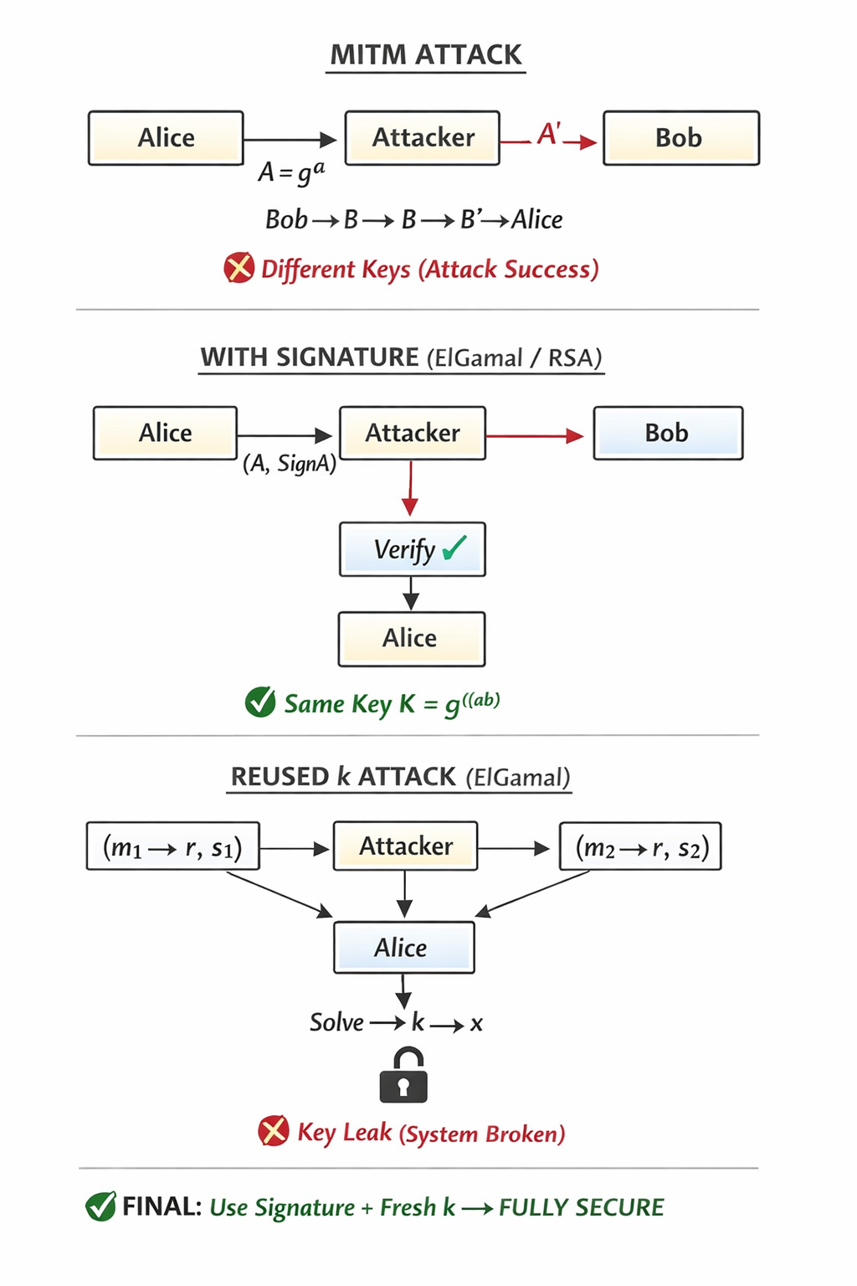

IMPLEMENTATION

This project implements a secure communication system using Diffie-Hellman key exchange for key exchange and ElGamal Digital Signature for authentication.
It demonstrates:
- Man-in-the-Middle (MITM) attack
- Reused nonce (k) attack
- Prevention using Cryptographic hash function, HMAC, and secure nonce generation

Vulnerable System Implementation
Code Flow
Part A: Diffie-Hellman (No Authentication)
- Generate parameters $p,g$
- Alice computes $A=g^{a}$
- Bob computes $B=g^{b}$
- Exchange values over insecure channel
- Compute shared key:
$$K=g^{ab}$$

Part B: ElGamal Signature (Reuse of k)
- Generate keys:
  - Private key $x$
  - Public key $y=g^{x}$
- Choose same nonce $k$
- Sign two messages:
  - $\left(r , s_{1}\right)$for $m_{1}$
  - $\left(r , s_{2}\right)$for $m_{2}$

Explanation
- DH without authentication → vulnerable to MITM
- ElGamal with reused $k$→ vulnerable to key leakage
System is insecure at both levels

Attack Implementation

MITM Attack on Diffie-Hellman
Code Flow
- Alice sends $A$
- Attacker replaces:
$$A→A^{'}$$
- Bob sends $B$
- Attacker replaces:
$$B→B^{'}$$
- Keys:
  - Alice: $K_{1}=(B^{'})^{a}$
  - Bob: $K_{2}=(A^{'})^{b}$
  - Attacker computes both

Explanation
- No authentication → attacker impersonates both sides
- Two different keys formed
- Communication fully compromised

Pseudo Algorithm – MITM Attack
- Input: $p,g$
- Alice computes $A$
- Attacker sends fake $A^{'}$
- Bob computes $B$
- Attacker sends fake $B^{'}$
- Alice computes $K_{1}$
- Bob computes $K_{2}$
- Attacker computes both keys
- Attack successful

Reused k Attack in ElGamal
Code Flow
- Capture:
  - $\left(r,s_{1}),(r,s_{2}\right)$
- Compute:
$$k=(m_{1}-m_{2})(s_{1}-s_{2})^{-1}$$
- Recover:
$$x=(m_{1}-s_{1}k)⋅r^{-1}$$

Explanation
- Same $k$→ same $r$
- Linear equations → solvable
Private key leaked

Pseudo Algorithm – Reused k Attack
- Input: $m_{1},m_{2},s_{1},s_{2},r$
- Compute $Δm=m_{1}-m_{2}$
- Compute $Δs=s_{1}-s_{2}$
- Compute inverse $\left(Δs)^{-1}\right.$
- Compute $k$
- Compute $x$
- Output private key

Prevention Mechanisms

SHA-Based Integrity
Code Flow
- Compute:
$$h=SHA(A)$$
- Send $\left(A , h\right)$
- Receiver verifies hash

Explanation
- Detects modification
- Ensures integrity
Cannot prevent MITM alone

HMAC-Based Authentication
Code Flow
- Shared secret key $K_{s}$
- Compute:
$$H=HMAC(K_{s},A)$$
- Send $\left(A , H\right)$
- Verify at receiver

Explanation
- Provides:
  - Integrity
  - Authentication
Prevents MITM

Secure ElGamal Signature
Code Flow
- For each message:
  - Generate fresh $k$
- Compute:
$$r=g^{k} \\ s=k^{-1}(m-xr)$$

Explanation
- Unique $k$→ unique $r$
- No linear relation
- Attack impossible

Pseudo Algorithm – Prevention
- Input: message $m$
- Generate random $k$
- Ensure $k$is unique
- Compute $r$
- Compute $s$
- Output signature

Final System Behavior
Stage | Result
DH only | ❌ MITM possible
DH + SHA | ⚠️ Detects only
DH + HMAC | ✅ Secure
ElGamal reused k | ❌ Key leak
ElGamal fresh k | ✅ Secure

RESULTS AND GRAPHS

DH MITM
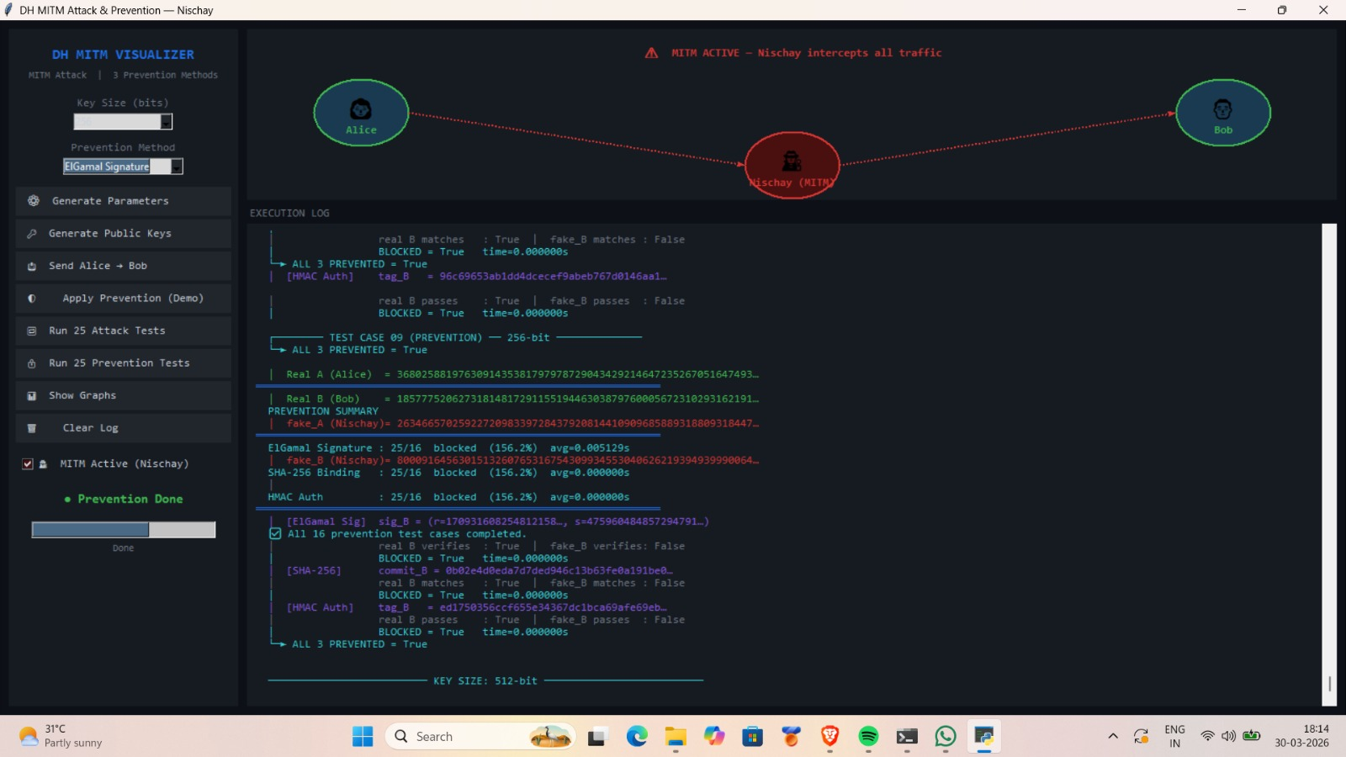

GRAPHS
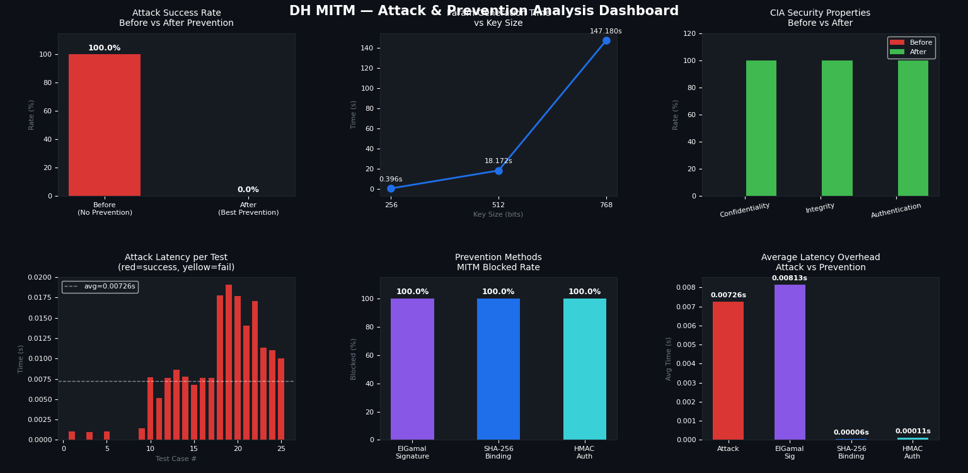

1. Attack Success Rate (Before vs After Prevention)
- Before applying security → 100% attack success
- After applying prevention → 0% success
Shows that authentication methods completely eliminate MITM attacks.

2. Performance vs Key Size
- As key size increases (256 → 768 bits), time increases significantly
- Larger keys → more security but higher computation cost
Demonstrates security vs performance trade-off.

3. CIA Security Properties (Before vs After)
- Before: Confidentiality, Integrity, Authentication were weak
- After: All reach 100% effectiveness
Shows system becomes fully secure after prevention.

4. Attack Latency per Test
- Each bar = time taken per attack attempt
- Red bars = successful attacks
- Average latency ≈ 0.00726 sec
Shows attacks are fast and practical without protection.

5. Prevention Methods (Blocked Rate)
- ElGamal Signature → 100% blocked
- SHA-256 Binding → 100% blocked
- HMAC Authentication → 100% blocked
All methods effectively prevent MITM attacks.

6. Average Latency Overhead
- Attack latency ≈ 0.00726 sec
- ElGamal adds small overhead (~0.00813 sec)
- SHA & HMAC add very minimal overhead
Security improvements come with negligible extra cost.

Reuse k – Graphs
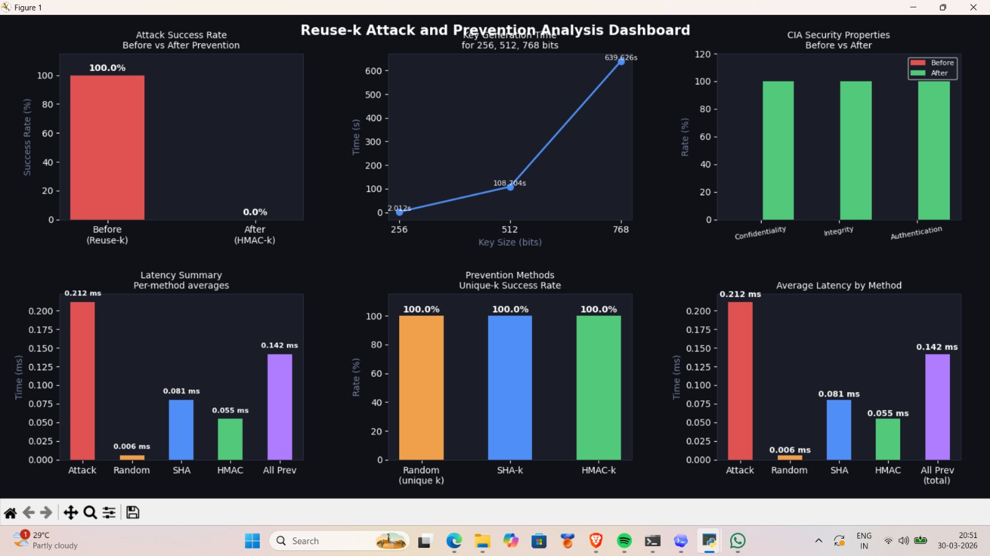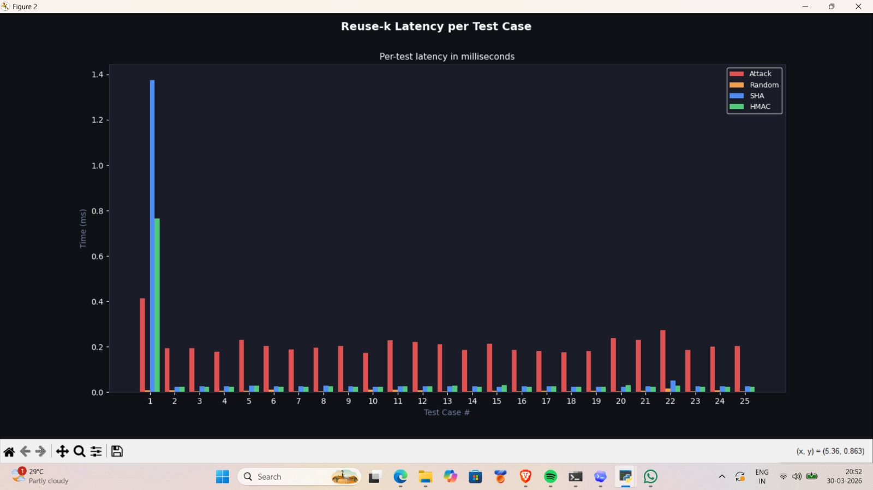

1. Attack Success Rate (Before vs After)
- Before (reuse-k) → 100% attack success
- After (HMAC / secure k) → 0% success
Reusing $k$always leaks the private key, but prevention fully stops it.

2. Key Generation Time vs Key Size
- Time increases heavily from 256 → 768 bits
- Larger key size → higher security but slower computation
Shows performance vs security trade-off.

3. CIA Security Properties
- Before → Weak (due to key leakage)
- After → 100% Confidentiality, Integrity, Authentication
System becomes fully secure after fixing reuse-k.

4. Latency Summary (Per Method)
- Attack ≈ highest time (~0.21 ms)
- Random k ≈ very fast (~0.006 ms)
- SHA ≈ moderate
- HMAC ≈ slightly higher than SHA
Prevention methods are efficient and lightweight.

5. Prevention Methods (Success Rate)
- Random k → 100% secure
- SHA-based k → 100% secure
- HMAC-based k → 100% secure
Any method ensuring unique k prevents attack completely.

6. Average Latency by Method
- Attack takes more time
- Random k is fastest
- SHA and HMAC add small overhead only
Security improvements have minimal performance cost.
7. Reuse-k Latency per Test Case (Graph 2)
- Attack (red) consistently higher latency
- SHA (blue) and HMAC (green) are stable and low
- First test slightly higher due to initialization overhead
Shows system becomes stable and efficient after prevention.

LIMITATION AND CONCLUSION

Limitations
- Lack of Authentication in Key Exchange
The Diffie-Hellman key exchange does not provide identity verification, making it inherently vulnerable to Man-in-the-Middle attacks.
- Dependency on Secure Parameter Usage
The security of cryptographic systems depends heavily on correct parameter selection (prime $p$, generator $g$, nonce $k$). Weak or reused parameters can break the system.
- Nonce Sensitivity in Signatures
In ElGamal Digital Signature, reuse or predictability of the nonce $k$directly leads to private key compromise.
- Computational Complexity
Cryptographic operations (modular exponentiation, hashing) become expensive as key size increases, affecting performance in large-scale systems.
- Reliance on Hard Mathematical Problems
Security depends on problems like discrete logarithm. If these problems become solvable (e.g., via quantum computing), the system becomes insecure.
- No Built-in Integrity or Authentication (in Basic Forms)
Basic versions of protocols do not guarantee integrity or authenticity unless combined with additional mechanisms like Cryptographic hash function or HMAC.
- Implementation Sensitivity
Even strong algorithms can fail if implemented incorrectly (e.g., poor randomness, improper key handling).

Conclusion
This study highlights both the strengths and vulnerabilities of fundamental cryptographic techniques used for secure communication.
The Diffie-Hellman key exchange enables secure key exchange over insecure channels but fails to provide authentication, making it vulnerable to Man-in-the-Middle attacks. On the other hand, the ElGamal Digital Signature ensures authenticity, but improper use of parameters particularly the reuse of nonce $k$ can completely compromise security.
The analysis shows that combining cryptographic techniques with proper safeguards—such as authentication mechanisms and unique nonce generation effectively mitigates these vulnerabilities. Additionally, the use of secure hashing and message authentication ensures data integrity and prevents unauthorized modifications.

Bibliography
[1] W. Stallings, Cryptography and Network Security: Principles and Practice, 7th ed. Hoboken, NJ, USA: Pearson Education, 2017.
[2] A. J. Menezes, P. C. van Oorschot, and S. A. Vanstone, Handbook of Applied Cryptography. Boca Raton, FL, USA: CRC Press, 1996.
[3] B. Schneier, Applied Cryptography: Protocols, Algorithms, and Source Code in C, 2nd ed. New York, NY, USA: John Wiley & Sons, 1996.
[4] C. Paar and J. Pelzl, Understanding Cryptography: A Textbook for Students and Practitioners. Berlin, Germany: Springer-Verlag, 2010.
[5] B. A. Forouzan, Cryptography and Network Security. New York, NY, USA: McGraw-Hill, 2007.
[6] J. Katz and Y. Lindell, Introduction to Modern Cryptography, 3rd ed. Boca Raton, FL, USA: CRC Press/Chapman & Hall, 2020.
[7] M. Bishop, Computer Security: Art and Science, 2nd ed. Boston, MA, USA: Addison-Wesley/Pearson, 2018.
[8] C. Kaufman, R. Perlman, and M. Speciner, Network Security: Private Communication in a Public World, 2nd ed. Upper Saddle River, NJ, USA: Prentice Hall, 2002.
[9] D. R. Stinson and M. Paterson, Cryptography: Theory and Practice, 4th ed. Boca Raton, FL, USA: CRC Press, 2018.
[10] N. Ferguson, B. Schneier, and T. Kohno, Cryptography Engineering: Design Principles and Practical Applications. Indianapolis, IN, USA: Wiley Publishing, 2010.

